**REST - Get country based on country code**

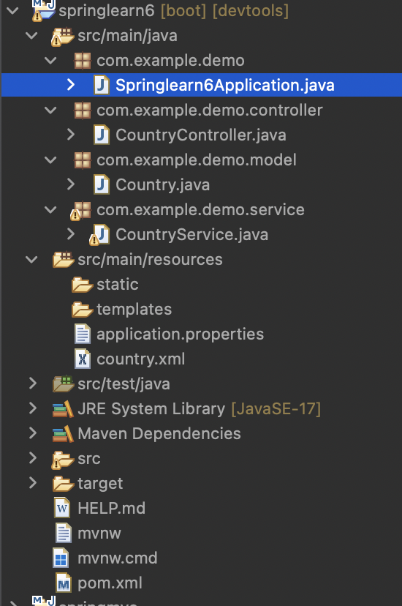

package com.example.demo;

import org.springframework.boot.SpringApplication;

import org.springframework.boot.autoconfigure.SpringBootApplication;

@SpringBootApplication

public class Springlearn6Application {

public static void main(String[] args) {

SpringApplication.run(Springlearn6Application.class, args);

}

}

package com.example.demo.controller;

import org.springframework.beans.factory.annotation.Autowired;

import org.springframework.web.bind.annotation.GetMapping;

import org.springframework.web.bind.annotation.PathVariable;

import org.springframework.web.bind.annotation.RestController;

import com.example.demo.model.Country;

import com.example.demo.service.CountryService;

*@RestController*

public class CountryController {

*@Autowired*

private CountryService countryService;

*@GetMapping*("/countries/{code}")

public Country getCountry(*@PathVariable* String code)

{

return countryService.getCountry(code);

}

}

package com.example.demo.model;

public class Country {

private String code;

private String name;

public Country() {}

public Country(String code, String name) {

super();

this.code = code;

this.name = name;

}

public String getCode() {

return code;

}

public void setCode(String code) {

this.code = code;

}

public String getName() {

return name;

}

public void setName(String name) {

this.name = name;

}

}

package com.example.demo.service;

import org.springframework.stereotype.Service;

import com.example.demo.model.Country;

import java.util.List;

import org.springframework.context.ApplicationContext;

import org.springframework.context.support.ClassPathXmlApplicationContext;

*@Service*

public class CountryService {

public Country getCountry(String code)

{

ApplicationContext context=new ClassPathXmlApplicationContext("country.xml");

List<Country> countryList=(List<Country>)context.getBean("countryList");

return countryList.stream()

.filter(country->country.getCode().equalsIgnoreCase(code))

.findFirst()

.orElse(null);

}

}

<?**xml** version=*"1.0"* encoding=*"UTF-8"*?>

<**beans** xmlns=*"http://www.springframework.org/schema/beans"*

xmlns:xsi=*"http://www.w3.org/2001/XMLSchema-instance"*

xsi:schemaLocation=*"*

*http://www.springframework.org/schema/beans*

*http://www.springframework.org/schema/beans/spring-beans.xsd"*>

<**bean** id=*"countryList"* class=*"java.util.ArrayList"*>

<**constructor-arg**>

<**list**>

<**bean** class=*"com.example.demo.model.Country"*>

<**property** name=*"code"* value=*"IN"*/>

<**property** name=*"name"* value=*"India"*/>

</**bean**>

<**bean** class=*"com.example.demo.model.Country"*>

<**property** name=*"code"* value=*"US"*/>

<**property** name=*"name"* value=*"United States"*/>

</**bean**>

<**bean** class=*"com.example.demo.model.Country"*>

<**property** name=*"code"* value=*"CN"*/>

<**property** name=*"name"* value=*"China"*/>

</**bean**>

</**list**>

</**constructor-arg**>

</**bean**>

</**beans**>

spring.application.name=springlearn6

server.port=8083

Pom.xml

<?xml version="1.0" encoding="UTF-8"?>

<project xmlns="http://maven.apache.org/POM/4.0.0" xmlns:xsi="http://www.w3.org/2001/XMLSchema-instance"

xsi:schemaLocation="http://maven.apache.org/POM/4.0.0 https://maven.apache.org/xsd/maven-4.0.0.xsd">

<modelVersion>4.0.0</modelVersion>

<parent>

<groupId>org.springframework.boot</groupId>

<artifactId>spring-boot-starter-parent</artifactId>

<version>3.5.3</version>

<relativePath/> <!-- lookup parent from repository -->

</parent>

<groupId>com.cognizant</groupId>

<artifactId>springlearn6</artifactId>

<version>0.0.1-SNAPSHOT</version>

<name>springlearn6</name>

<description>Demo project for Spring Data JPA and Hibernate</description>

<url/>

<licenses>

<license/>

</licenses>

<developers>

<developer/>

</developers>

<scm>

<connection/>

<developerConnection/>

<tag/>

<url/>

</scm>

<properties>

<java.version>17</java.version>

</properties>

<dependencies>

<dependency>

<groupId>org.springframework.boot</groupId>

<artifactId>spring-boot-starter-web</artifactId>

</dependency>

<dependency>

<groupId>org.springframework.boot</groupId>

<artifactId>spring-boot-devtools</artifactId>

<scope>runtime</scope>

<optional>true</optional>

</dependency>

<dependency>

<groupId>org.springframework.boot</groupId>

<artifactId>spring-boot-starter-test</artifactId>

<scope>test</scope>

</dependency>

</dependencies>

<build>

<plugins>

<plugin>

<groupId>org.springframework.boot</groupId>

<artifactId>spring-boot-maven-plugin</artifactId>

</plugin>

</plugins>

</build>

</project>

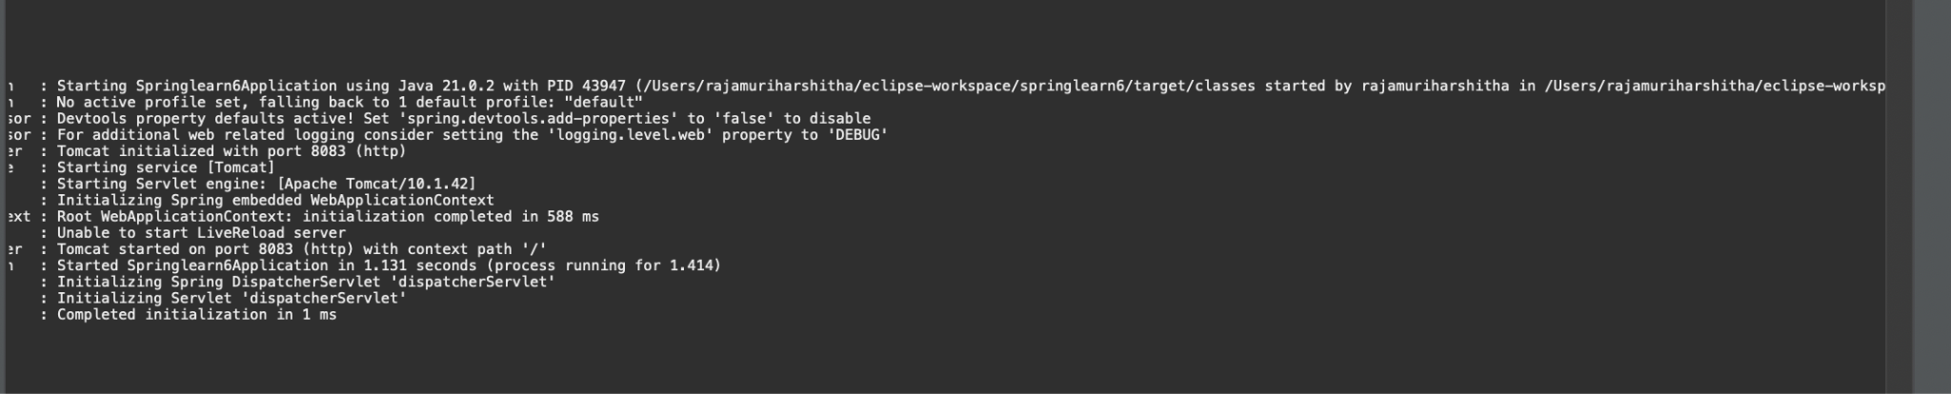

Required Output:

